**EXPERIMENT-7**

NAME-JAYESH MAHAJAN

ROLL NO-11

PRN NO-1032220100

**Remove duplicate, inaccurate data, and empty rows in your data.**

**Assignment A:**



**Assignment B:**

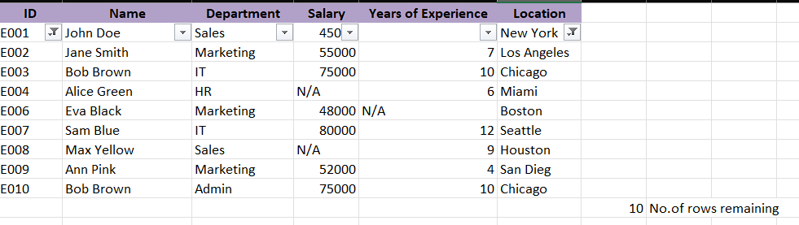

### **1. Removing Duplicate Data:**

* Open your Excel file.
* Select the range of data where you want to remove duplicates.
* Go to the **Data** tab.
* Click **Remove Duplicates** in the Data Tools group.
* Select the columns where duplicates might exist.
* Click **OK** to remove duplicates.

### **2. Removing Empty Rows:**

* Select the entire worksheet or the specific range of rows where you want to remove empty rows.
* Press **Ctrl + G** to open the **Go To** dialog.
* Click on **Special**.
* Choose **Blanks** and click **OK**.
* Right-click on one of the selected blank cells and choose **Delete**.
* Select **Entire Row** and click **OK** to remove all empty rows.

### **3. Fixing Inaccurate Data:**

* Check the data for any values that seem incorrect or out of range.
* You can use **Data Validation** under the **Data** tab to ensure data fits expected criteria.
* Set conditions (e.g., numbers within a range or specific text criteria).
* Fix any highlighted errors manually.